Gateways | Join Latency
1 | 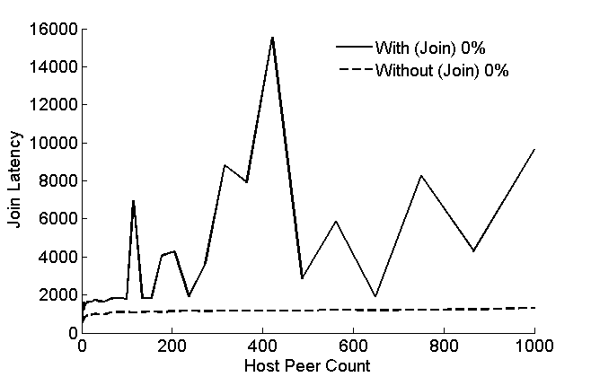 | N/A  (Join only)
10% | 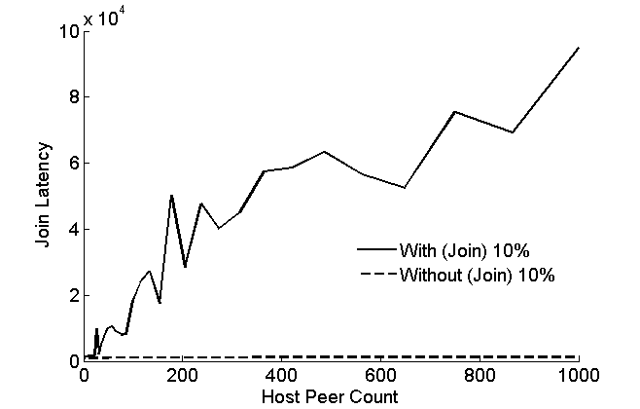 | N/A  (Join only)
50% | 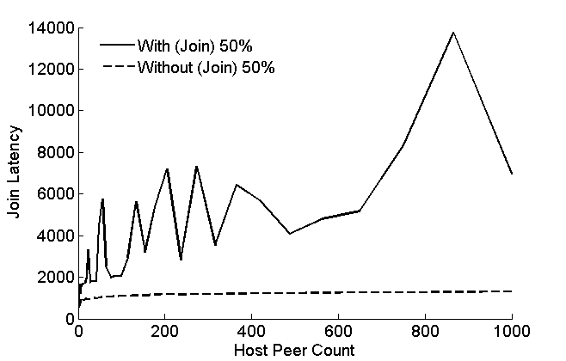 | N/A  (Join only)
90% | 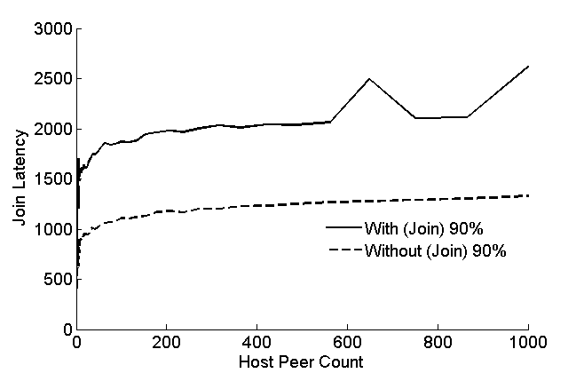 | N/A  (Join only)
100% | 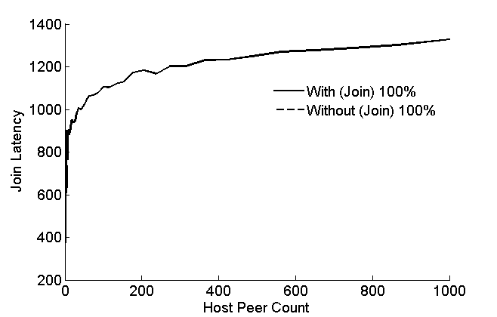 | N/A  (Join only)

